**Kenya medical training college**

**Machakos campus**

**C.O.T.M September class**

**Casting and Traction Technique**

**Below Elbow Cast/ Thumb Spica Cast**

**Below elbow cast**

**Introduction**

* The short arm cast is also known as the *below-elbow cast*. This is a frequently used circumferential immobilization cast of the forearm and wrist made of either synthetic material or plaster of Paris, used as a treatment for fractures and soft tissue injuries of the forearm

**Indication**

* the forearm distal forearm fractures,
* carpal and wrist injuries,
* pediatric buckle fracture
* immobilization of after surgery.

**Required materials**

**An external file that holds a picture, illustration, etc.
Object name is 746fig1.jpg**

Applying the cast: • The first layer of padding should wrap around the limb in two complete rotations prior to advancing the roll, creating 2 layers of padding at the proximal most aspect. • Commence plaster wrapping. Start distally to the injury ensuring not to breech the limits of the soft ban wrap. • Unroll the plaster of Paris rolls over the limb, taking care not to pull excessive tension on the roll. • The first layer of plaster should complete two full rotations directly over each other prior to advancing the roll down the limb. • Continue to advance the plaster roll down the limb, wrapping 66% to create 3 layers of cast. • Upon reaching the hand, ensure casting terminates prior to the distal palmar crease. • Advance the cast between the thumb and fore-finger by creating a curved cut and continue. • 2 Layers of plaster between thumb and fore finger are sufficient. • Upon completing the first roll of plaster fold the soft ban edges back over the plaster layer to create an edge at the distal and proximal aspects. • Repeat the plaster roll wrap again starting proximally, capturing the rolled back soft ban edges, and advancing down the limb creating 6-8 layers of plaster. • Laminate plaster layers by rubbing plaster between flat palms. • As the plaster hardens and dries, it warms up. • Place the drying cast on a pillow and allow to set for 20 minutes prior to application of sling.

An external file that holds a picture, illustration, etc.
Object name is 746fig3.jpg

An external file that holds a picture, illustration, etc.
Object name is 746fig4.jpg

An external file that holds a picture, illustration, etc.
Object name is 746fig5.jpg

An external file that holds a picture, illustration, etc.
Object name is 746fig6.jpg

An external file that holds a picture, illustration, etc.
Object name is 746fig7.jpg

An external file that holds a picture, illustration, etc.
Object name is 746fig8.jpg

**Complication**

* stiffness,
* pressure sores
* compartment syndrome
* muscle atrophy
* Neurapraxia
* Ischemic injury

**Contraindication**

* Open fractures
* Excessive swelling

Injury to radial nerve

Injury to median nerve

**Thumb Spica cast**

**Introduction**

This **casts** can go from just below the elbow to the knuckles but include the **thumb** or from the wrist and up the **thumb**

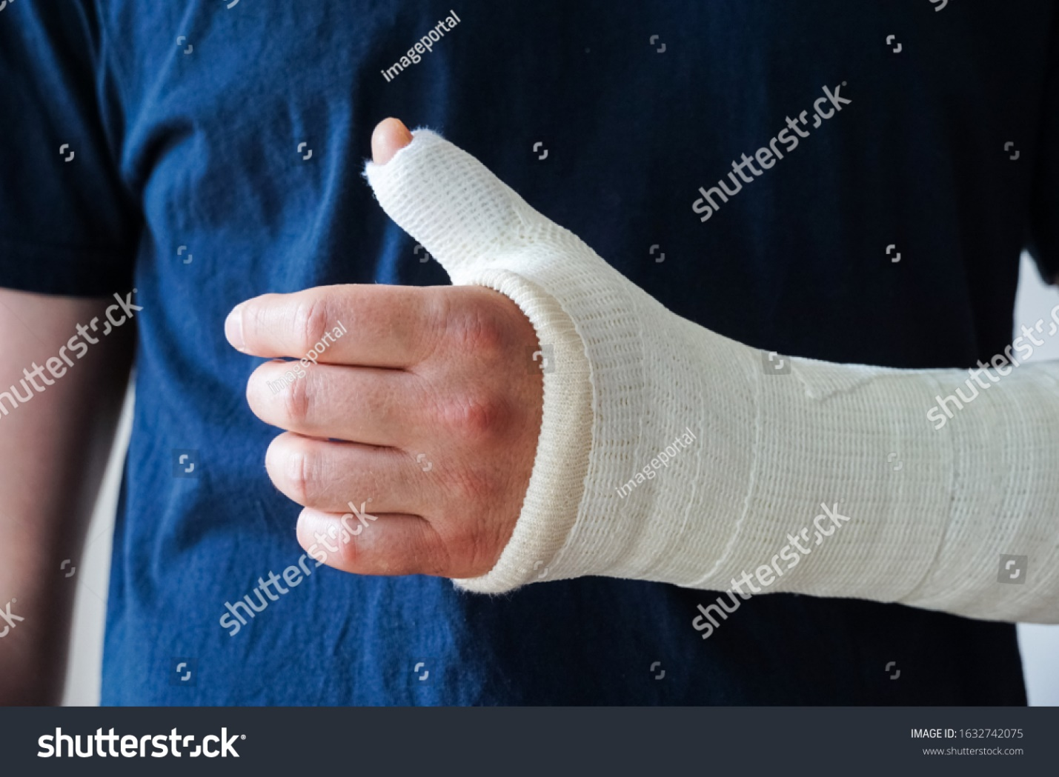

**Indication**

* Scaphoid injuries.
* Lunate injuries.
* First metacarpal fractures.
* Injury to the ulnar collateral ligament (UCL)
* Positioning for de Quervain tenosynovitis.

**Complication**

* stiffness,
* pressure sores
* compartment syndrome 5p

 pain, pallor (pale skin tone), paresthesia (numbness feeling), pulselessness (faint pulse) and paralysis (weakness with movements)

* muscle atrophy

Contraindication

Open fracture

Injury to median nerve

Excessive swelling